The Lighthouse Voc-Ed Center Inc.

Reopening Plan for Life Campus

Based upon guidance from the Connecticut State Department of Education, Centers for Disease Control, and the State of Connecticut Reopening Team, The Light House has developed a comprehensive Reopening Plan to provide in-person programming. The plan was created to be reviewed by families, staff, providers, and participants to ensure understanding and shared commitment to the health and safety of all LH community members. Corresponding companion documents included in the plan outline specific policy and protocol to be followed by staff and participants, but may be subject to change as situations evolve. This plan covers all participants who live at the Life Campus, outside participants who visit for the day and Friday Friends.

Index:

- Health Liaison, Communication Plans, and Distribution of Information
- Physical Distancing, and PPE
- Enhanced Cleaning, Hygiene, and Sanitization Procedure
- Transportation
- Health Screening for Staff, Participants, and Visitors
- Responding to COVID-19 Symptoms and Cases
- Staff Training

Appendix A COVID-19 Risk Acknowledgment
Appendix B Staff Cleaning Expectations
Appendix C Temperature and Symptom Monitoring Form

I. Health Liaison, Communication Plans, and Distribution of Information

The Light House Director of Operations - LIVECTA will serve as the COVID-19 Health and Safety Compliance Liaison. In the event the designated COVID-19 Health and Safety Compliance Liaison is out sick or unavailable, the Operations Manager will fill in for that role. The Light House Life Campus Reopening Plan will be posted on The Light House website as well as made available through email. Any future updates on policies and protocols related to this plan or any new plans, will be distributed through email and made available on our website.

The Light House Director of Operations - LIVECTA, as well as staff, will maintain frequent communication with parents and guardians about any and all changes prior to and during opening. Due to the critical nature of some of these updates, all parents and guardians are encouraged to check The Light House’s website, and their email regularly.

II. Physical Distancing, and PPE

Physical Distancing

Staff and participants will be expected to adhere to physical distancing guidelines (>6 ft.), when possible. Staff will be trained to work with individuals to assist or intervene as necessary, providing alternative spacing or programming arrangements when needed.

PPE

Personal Protective Equipment (PPE) will be provided to all staff members and participants, including the provision of two cloth masks. N95 and surgical grade masks and visors, gloves, and gowns are also on site for situations that require them.

- Staff are required to wear face masks or face shields at all times while indoors and when in close proximity to others.
- Participants will be required to wear face masks or face shields while attending the program. If they are unable or unwilling to wear a mask they may still attend the program. Alternative spacing or programming arrangements will be used in these instances. A participant is exempt from wearing a mask if they have trouble breathing or are unconscious, incapacitated, or otherwise unable to remove the mask without assistance. If they have a medical reason making it unsafe to wear a face covering, they are also not required to wear a mask. Participants will also be required to wear face masks or face shields in LH transportation.

Staff will ensure that enhanced PPE requirements are followed (i.e. masks, visors, and gloves) when in close contact with bodily fluids. Enhanced PPE will also be used when physical distancing and/or face covering requirements cannot be met by the participants they are working with.

III. Enhanced Cleaning, Hygiene, and Sanitization Procedures

Hygiene

All staff and participants will be required to regularly wash or sanitize their hands throughout the day and upon entry to the building. Staff will promote healthy hygiene habits by modeling and teaching correct hand washing techniques and prompting individuals to cover when coughing or sneezing. Regular hand washing includes:
- Before coming in contact with participants;
- Before and after eating;
- After sneezing, coughing, or nose blowing;
- After using the restroom;
- Before handling food;
- After touching or cleaning surfaces that may be contaminated; and
- After using any shared equipment like toys, computer keyboards, radios.

Cleaning and Disinfecting

Intensified cleaning and disinfecting protocols will be implemented at the end of the day by staff. Staff will also be required to do spot cleaning and disinfecting regularly for all touch surfaces, in accordance with the Staff Cleaning Expectation Policy (Appendix B) under guidance of the director. Disposable wipes will be made available at all shared facilities and equipment in the building.

IV. Transportation

PPE

In order to safely transport, all staff and participants will be required to wear a face covering (masks or face shields) while in the vehicles. Safe physical distancing is not always possible in vehicles and, therefore, the CDC recommends all individuals (including the driver) wear face coverings.

Routine Cleaning and Disinfecting

All vehicles will be cleaned after each use and deep cleaned at least once per week. Staff will be instructed to use disinfectant wipes to wipe down all touch surfaces, including but not limited to: seat belts, steering wheel, shifter, radio, door handles both inside and outside, as well as door consoles (while wearing necessary PPE). Window ventilation will be used when practical.

Operating Capacity

The Light House plans to operate transportation, both for day travel and for pick-up, at full capacity while maximizing health and safety protocols, as outlined above. All participants will load into the van, back row to front and then unload from the van from front to back. It is the job of the staff to assist participants with not only putting on their face masks, but also loading and unloading in a controlled manner.

V. Health Screenings for Staff, Participants, and Visitors

All staff, participants, and visitors are required to be screened for any observable illness such as cough, shortness of breath, and any two of the following: fever, chills, repeated shaking with chills, muscle pain, headache, sore throat, new loss of taste or smell, and to confirm temperature is below 100.4℉. Anyone with a temperature over 100.4 degrees Fahrenheit or displaying symptoms of COVID-19 will not be permitted to come to program or be admitted into the facility.

The Light House will use the “Temperature and Symptom Monitoring Form” (appendix C) to screen as follows:

Participants
- Upon Pick Up (LH transportation): The Light House transportation staff will conduct a symptom and temperature screening in collaboration with the individual and parent/guardian upon pickup.
- Upon Arrival: When day participants arrive, they will have their temperature taken and be screened for symptoms of COVID-19.
- Start of Program: All participants will be screened for symptoms and have their temperature taken at the start of program.

Staff
- All staff are to arrive early to be screened and have their temperature taken by a supervisor or trained designee.

Visitor Policy

All non-essential visitors, guests and volunteers are not allowed to enter the building. All essential visitors and service providers who do enter are to follow the above screening practices. All essential visitors are also required to follow all PPE requirements in the building, hand washing policy and physical distancing policy.

Activities Policy

Participants are to disclose when attending non Light House sponsored activities to the Director of Operations - LIVECTA, before returning to program. This is not only for the safety of those in the program, but for contact tracing purposes.

Travel

It is recommended that staff and participants restrict their travel. If staff or participants have traveled to any of the states with high-infection rates, as defined under Executive Order 7BB, they will not be allowed to return to the program until they have met the mandated 14-day self-quarantine.

Dining

Staff and participants are not allowed to share utensils, plates, serving dishes or cooking ware. All staff and participants are to clean and disinfect the kitchen after each use. This includes, but is not limited, the stove, oven, microwave, sink, countertops, touched appliances and used cabinets. When preparing a shared meal, all staff and participants are to wear both masks and gloves. Whenever possible and safe, staff and participants may share meals but only when they can adequately social-distance.

Initial Employee and Participant Testing

All employees and participants will be required to receive a SARS-CoV2 test prior to returning to the program. Verification will need to be submitted on or before August 24th. Due to the recent 14-day delay in test results, employees and participants will need to schedule their test by August 7th. Further testing will be performed according to plans for suspected/confirmed case exposure.

VI. Responding to COVID-19 Symptoms and Cases

The following section identifies policies for handling suspected and confirmed cases of COVID-19, post-exposure protocols for confirmed cases, and the requirements for returning to work/program.

Definitions:

Confirmed COVID-19 Case: A confirmed case follows a positive result from a COVID-19 testing site.

Suspected case of COVID-19: A suspected case is when symptoms of COVID-19 are seen in the employee or participant. Symptoms of COVID-19 are fever (above 100.4 Fahrenheit), respiratory distress and/or the following: cough, chills, repeating shaking with chills, muscle pain, headache, sore throat, gastroenteritis, new loss of taste or smell. This combination of symptoms will be used by our staff to determine if a participant or staff is showing signs of COVID-19.

Test-Based Strategy: Resolution of fever without the use of fever-reducing medications, improvement in respiratory symptoms, and negative results from an authorized COVID-19 testing site. Negative results of an FDA Emergency Use Authorized molecular assay for COVID-19 from at least two consecutive nasopharyngeal swab specimens collected 24 hours apart. This is the only way for a staff member to return to work and one of two ways to determine if a participant may return to school after being suspected of having a case of COVID-19.

Time-Based Strategy: At least 10 days since symptoms first appeared in addition to 3 days’ fever free without the use of fever reducing medication and improvement in respiratory symptoms. The minimum number of days spent home in the time based strategy is 10 consecutive days.
This is the other way of determining if a participant may return to school following a suspected case of COVID-19. The Light House only allows participants to use the time-based strategy for returning to school.

Close Contact: The CDC defines close contact with somebody who is COVID-19 positive, as being within 6 feet for a prolonged period of time (10-30 minutes) or having direct contact with infectious secretions (being coughed on) from an individual who is COVID-19 positive.

Expectations of Supervisors and Managers

All supervisors and managers are expected to be familiar with this plan and be ready to answer questions from employees, parents, guardians and service providers. Familiarizing themselves with the symptoms of COVID-19, exposure risks, proper hygiene and work safety practices are paramount to reducing the spread of COVID-19 and keeping a safe program environment.

Screening and Suspected Cases

Staff, upon arrival, will be screened according to procedure. In the event a staff member is showing symptoms of COVID-19 during their shift, that staff member will immediately inform their supervisor and self-isolate. Management will then consult with HR and the agency nurse to make a determination. Any staff member who is sent home with ailments, but is not considered a suspected case, will follow our normal sick policy. If, due to the nature of their symptoms, they are considered suspected of having COVID-19 symptoms, they are required to follow a test-based strategy before returning to work. Staff members will be instructed to call their healthcare provider and follow their instructions as well.

Currently, all COVID-19 testing is free, however The Light House will pay for tests in the future if it is required. In the event the test returns with a positive result, the staff member will follow the guidance of their healthcare provider and the Department of Health. The Light House, while being as confidential with personal information as possible, will inform other staff, parents, guardians, and districts of a positive case of COVID-19. All Light House staff who were in close contact with that staff member will be required to be tested, per the test-based strategy, before returning to the program . Participants who were in close contact with that staff member will be required to be tested or follow the time-based strategy. At a minimum, the site will be closed for 24-48 hours for deep cleaning and disinfection but may be extended by the Director.

Participants, either upon arrival or at the start of the program in the morning, will be screened according to procedure. At lunch time, there will be a second screening of all participants. In the event a participant displays symptoms of COVID-19 and falls under suspected COVID-19 case, that participant will be isolated in their bedroom until picked up. Any outside participant in the program, who is a suspected COVID-19 case, they will not be allowed to enter the program. The Light House will not transport a participant displaying symptoms of COVID-19. Any participant who is sent home with suspected COVID-19 symptoms is required to follow either the test-based or time-based strategy before returning to the program. This is for the safety of all other participants and staff. Any participant who is sent home with ailments, but is not considered a suspected case, will follow our normal sick policy.

If a participant tests positive for COVID-19, that individual is to follow the guidelines of their healthcare provider and the Department of Health. If a participant is unable or unwilling to be tested for COVID-19, that individual is to follow the time-based strategy as outlined above, before returning to program. During this, while maintaining confidentiality to the participant’s personal information, all Light House staff, parents, guardians and districts will be notified of a positive COVID-19 case.

All Light House staff who were in close contact with that participant will be required to be tested, per the test-based strategy, before returning to the program. Participants who were in close contact with that participant will be required to be tested or follow the time-based strategy. At a minimum the site will be closed for 24-48 hours for deep cleaning and disinfection but may be extended by the Director.

In the event an employee or participant has close contact with a COVID-19 positive individual, they are to inform their supervisor or the program itself, respectively. An employee is to follow the guidance of their healthcare provider and when returning to work, follow the steps listed below as well as the instructions of HR.

Post-Exposure to Confirmed Cases of COVID-19

As outlined above, The Light House will follow CDC guidelines for returning to work or program. The test-based strategy is our preferred measure for participants and employees returning to program. In the event a participant cannot be tested, The Light House will use the time-based strategy but only for participants; it is required that employees follow the test-based strategy before returning to work/program.

An employee returning to work must be cleared by their healthcare provider and meet CDC required guidelines, which include resolution of fever, improvement in respiratory symptoms and two consecutive negative results from an authorized COVID-19 testing site. When an employee does return to work, they are to be restricted from contact with severely immunocompromised participants for at least two weeks since onset of symptoms, wear an N-95 mask, and be screened multiple times throughout the day for a fever and COVID-19 symptoms. In the event an employee shows symptoms of COVID-19 but tests negative twice, they are to follow The Light House’s sick policy and inform HR.

A participant is not allowed to return to in-person program until 14 days have passed, following a positive COVID-19 case, and approval of their healthcare provider. In the event a participant cannot return to program, remote services will be offered.

Contact Tracing

Following a confirmed case of COVID-19, as stated above, all Light House employees, parents, guardians, caregivers, related service providers and nurses will be notified as well as Ledge Light Health District and State of CT Department of Health. All contact tracing protocols, as outlined by the CDC, will be followed including the following…

- Case Investigation: LH management, in consultation with the agency nurse and public health staff (Ledge Light), will cross reference attendance records, employee time clocks, and daily screening logs to determine contacts for notification. The Light House COVID-19 Response Team will be notified as well.
- For COVID-19, a close contact is defined as any individual who was within 6 feet of an infected person for at least 10 minutes starting from 48 hours before the person began feeling sick until the time the patient was isolated.

Cancellation of Program, Remote Learning and Reopening Plans

In the event program has to be closed, remote learning will be offered to all participants. Only the Director of Operations - LIVECTA, Executive Director, or the State of CT can mandate a closure of the program. In the event of a shutdown, facilities will begin an immediate deep clean of the location. All program staff, including support staff, will be responsible for enacting the remote learning plan. Any necessary material needed for continuity of learning will also be provided to the participants, prior to the shutdown. In the event of any future closures, all plans will be communicated to families through email, on The Light House’s website, and if possible, delivered home with participants. In the event the State of CT orders the closure of the program, only the State of CT can decide when they open up.

Employee Leave Assistance

Under the Families First Coronavirus Response Act (FFCRA) as well as Emergency Paid Sick Leave Act (EPSLA), employees can receive up to two weeks of paid leave if they meet certain criteria:
- If an employee has been isolated due to federal, state or local mandate related to COVID-19
- If their healthcare provider has advised them to self-quarantine, either through exposure at work, or close contact with an individual who is positive for COVID-19
- When they are seeking diagnosis after showing symptoms of COVID-19, as defined above
- In the event they have to care for an individual who is subject to quarantine, such as a child or spouse
- If they have to stay home for childcare, in the event of a school closure or childcare provider, due to COVID-19

Employees should speak to Human Resources for questions related to paid leave vs non-paid leave, length of time off and rate of pay.

VII. Staff Training

All staff will undergo training in accordance with CDC guidelines that covers proper PPE usage, physical distancing strategies, cleaning and disinfecting procedures, hygiene, and LH screening and symptom identification. Staff will also be retrained on each individual’s health and safety guidelines in the context of enhanced safety protocols. All managers and designees that are required to conduct health screenings will receive additional training on symptom screening, identification, and suspected case protocol.

All signage is posted in compliance with both the State of CT and CDC. This includes correct hand washing measures at every sink, symptoms of COVID-19 at every entrance, correct ways to put on and take off masks, contact tracing, and social distancing practices throughout the building. More detailed signage is also posted in the employee break area.

Appendix A)
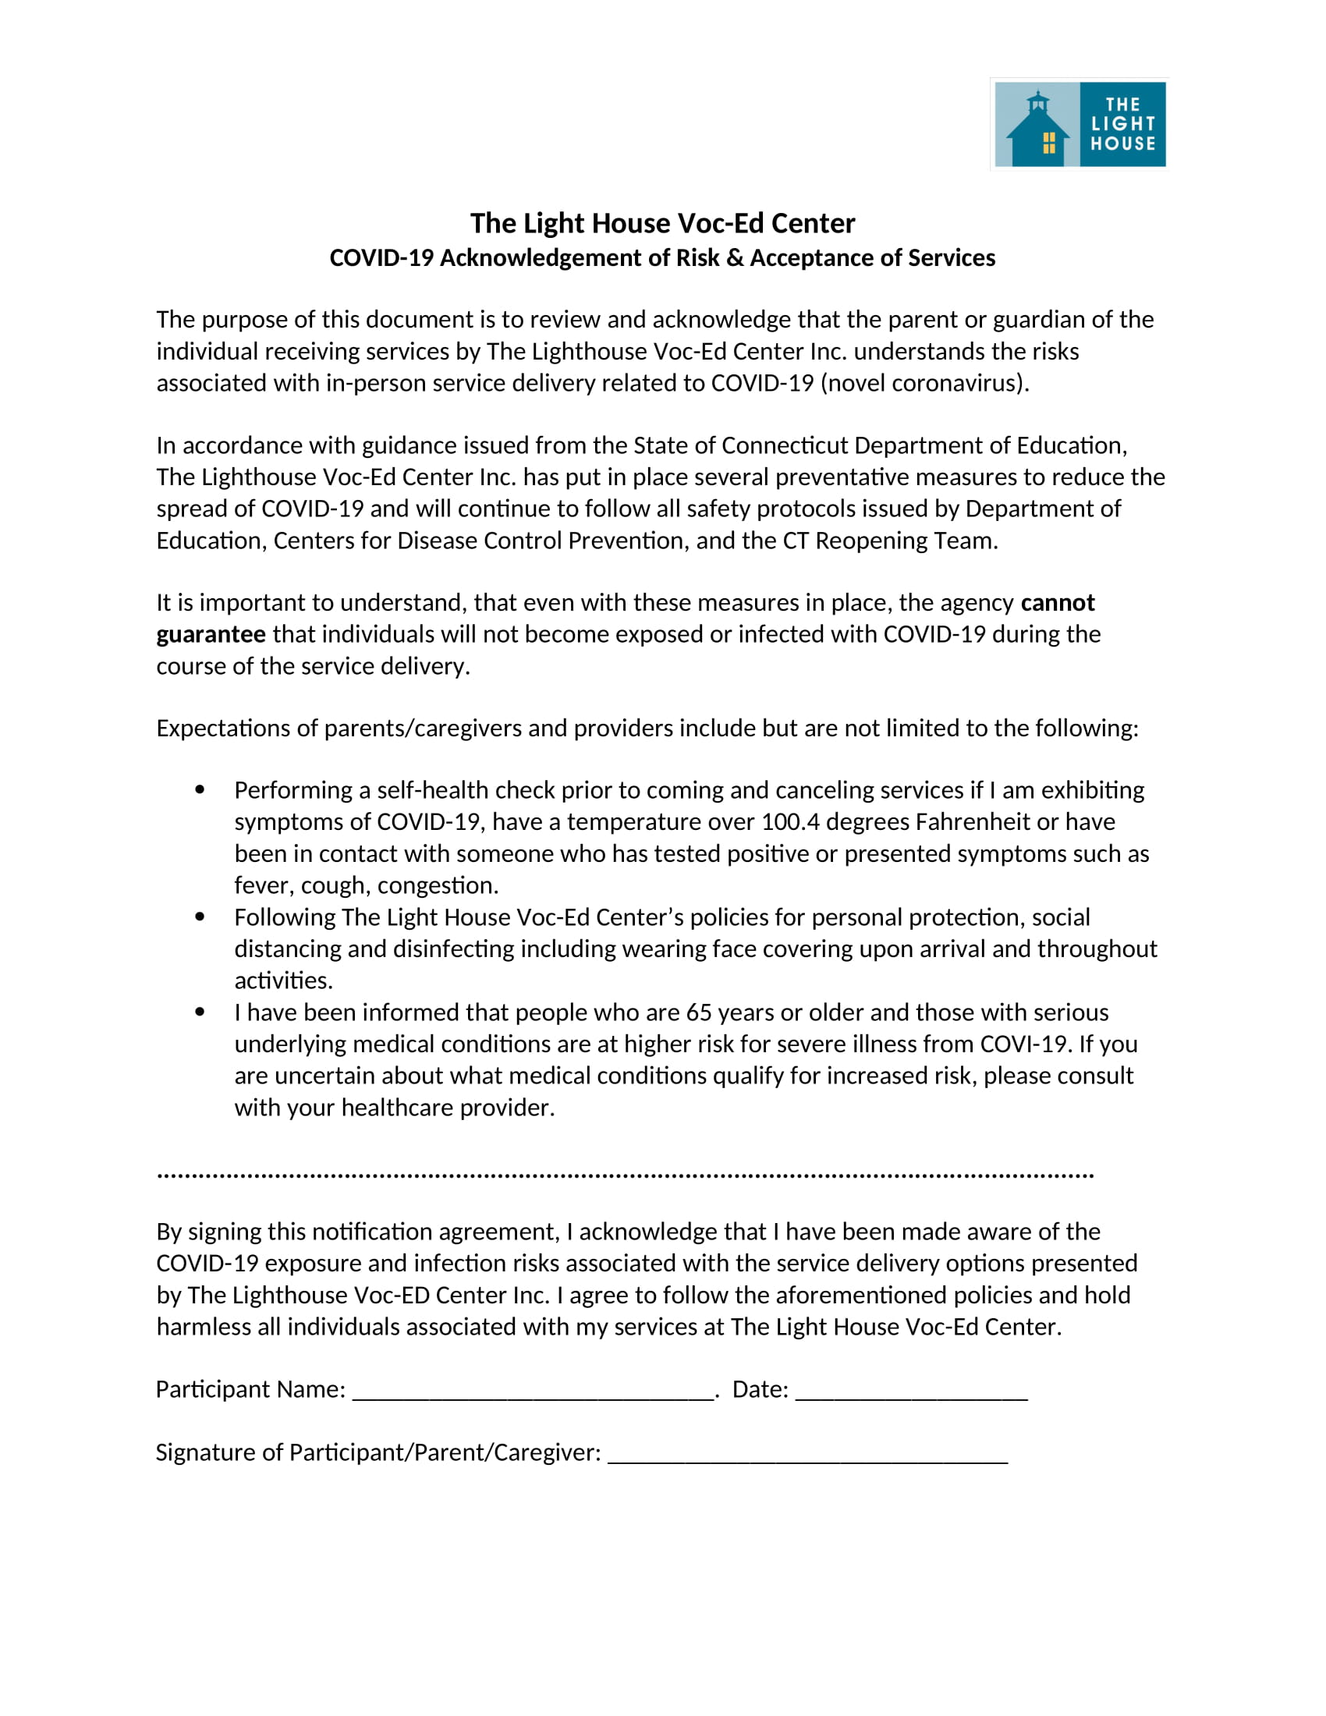
Appendix B)
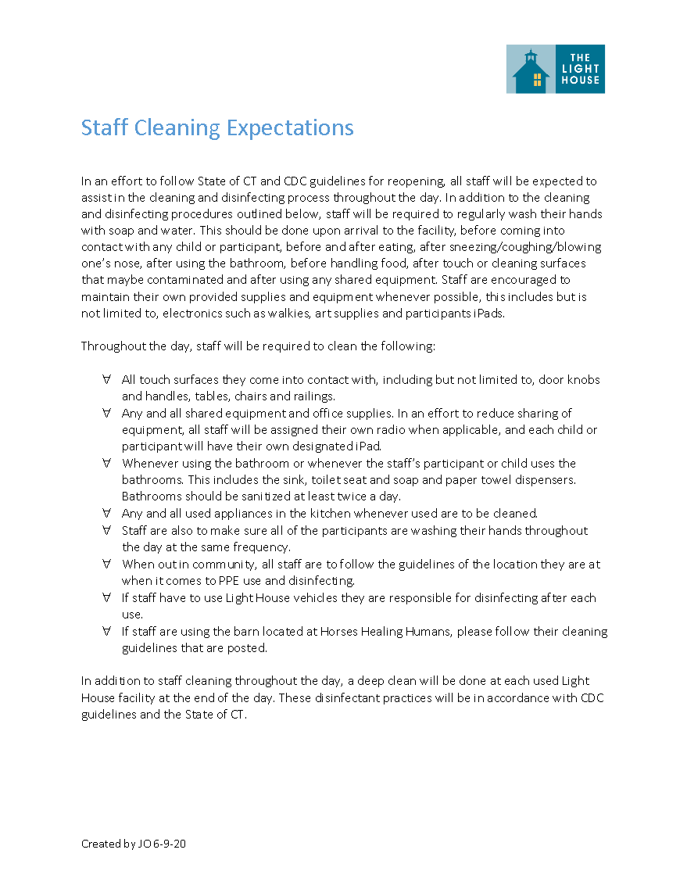

Appendix C)
